**User Guide for MongoDB Dashboard Environment**

This guide explains how to use the interactive dashboard to explore animal shelter data filtered by breed, age, and rescue type.

Table of Contents

Table of Contents 1

1. Revision History 2

2. Before Starting. 3

3. Dashboard access 4

4. Running the dashboard 5

5. Login Screen…………………………………………………………………………………………………..6  
 6. Dashboard View………………………………………………………………………………………………7  
 7. Overview…………………………………………………………………………………………………………8  
 8. Dashboard Control & Operation…………………………………………………………………………9  
 9. Download CSV……………………………………………………………………………………………….10  
 10. Download JSON……………………………………………………………………………………………..11  
 11. Notes & Exit…………………………………………………………………………………………………..12

## Document Revision History

| **Version** | **Date** | **Author** | **Comments** |
| --- | --- | --- | --- |
| 1.0 | 7/26/2025 | Matthew Guarino | Rough Draft |
| 1.1 | 8/2/2025 | Matthew Guarino | Title page, table of contents, document revision history, have been added. Screenshots of how to access the dashboard, instructions logging in, and rearrangement of wording. |
|  |  |  |  |

**Before Starting…**

* Make sure that MongoDB is running before launching the app
* Make sure that the helpers.py and crud.py are in the same folder or on the python path

Once you have successfully connected the database (MongoDB compass or mongosh shell) and ran the juypter notebook command

* See MongoDB Dashboard_Run_Instructions Rev1.1 for more details

The Juypter Notebook will open to its homes screen as seen below

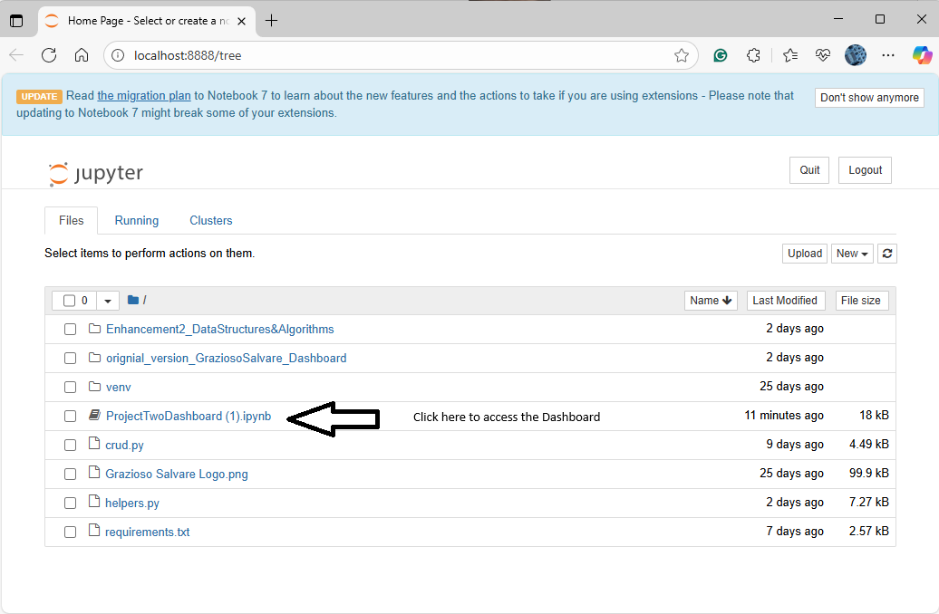

1. Click on the ProjectTwoDashboard(1).ipynb
2. You see the dashboard’s code opened and the layout should look like this

1. You’ll notice that when you scroll down to the bottom of the cell block that you’ll see this

1. This is expected because in order for the dashboard to work, you have to run the cell block first.
   * NOTE: Disregard the User Warning (Just telling you that there’s a better version of dash to use

1. Click > Run and the cell block should turn green and dashboard will start to work.
2. There are two options here for going forward- you can continue to use the dashboard below the cell block OR click on the URL to open up a new tab for the login screen.
   * I recommend clicking the link to open the dashboard in a new tab. Not every function of the dashboard will fit in the cell block’s window.

1. Login in with the provided credentials
   * U: admin - P: admin123
   * U: aacuser - P: guest123

Once logged into, you should have full access to the dashboard shown below.

Notice how the dashboard opens with nothing displayed, this is normal. Even with clicking radio buttons in rescue types or filtering by breed, nothing will be displayed.

1. Sort by either name, breed, or Age(weeks)
2. Then you can change the rescue type (which is preset from CS340) or filter by breed.

**Overview**

The dashboard allows users to:

- Filter animals by predefined rescue types (Water, Mountain, Disaster)

- Sort and view results by name, age, or breed

- Perform age-range queries using a binary search tree (BST)

- Filter by breed using an in-memory breed index

- Export data by CSV or JSON

**🧭 Dashboard Control and Operation**

🐶 Rescue Type Dropdown

- Filter dogs by Water, Mountain, or Disaster categories

- Each category applies filters based on breed, age, and sex

📊 Sort By Dropdown

- Sort results by:

- Name

- Breed

- Age (in weeks)

🔍 Breed Filter

- Narrow results to a specific breed using a dropdown menu

- Uses in-memory index for fast filtering

🧮 Age Range Filter

- Enter a minimum and maximum age (in weeks)

- Uses BST logic to retrieve results in that range

📈 Output Table

- Displays the filtered dataset in real time

- Columns: name, breed, sex, age, outcome, etc.

- Supports 50–100 sample records for test/demo purposes

**💾** Download CSV

* Exports the current filtered results into a .csv file
* Useful for offline data analysis in Excel
* Triggered by clicking the Download CSV button
* File name: filtered_animals.csv

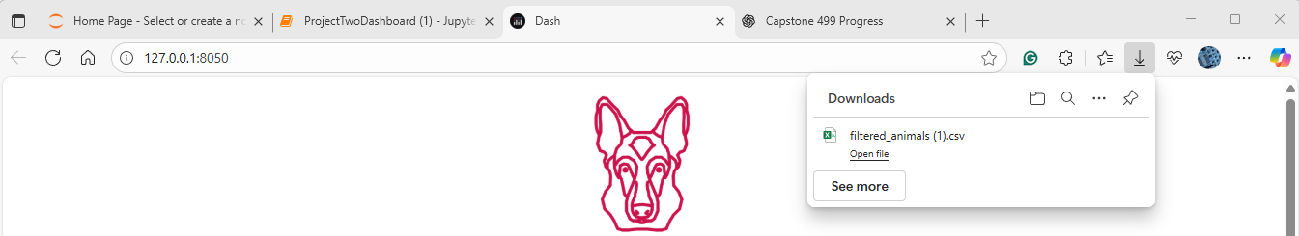

In this specific case – I filtered the Water Rescuse dogs and downloaded the CSV file

**💾** Download JSON

* Exports the current filtered results into a .json file
* Useful for developers or advanced data workflows
* Triggered by clicking the **Download JSON** button
* File name: filtered_animals.json

💡 Notes

- If no results appear, make sure you cleared old filters or entered a valid breed/age range

- The dashboard auto-refreshes on each input change

- BST and breed index logic is handled in `helpers.py`

❌ How to Exit

If running via notebook: stop the kernel

If running as `.py` app: press Ctrl+C in the terminal